KARTHIK KRISHNAN
S2 CSE B
ROLL: 45

LAB - 8
C PROGRAMMING
28-04-2024
Menu Driven Program

QN) Write a menu driven program for performing matrix addition, multiplication and finding the transpose. Use functions to (i) read a matrix, (ii) find the sum of two matrices, (iii) find the product of two matrices, (i) find the transpose of a matrix and (v) display a matrix.

Ans:

Program Code

#include<stdio.h>
void readMatrix(int [5] [5], int, int);
void printMatrix(int [5] [5], int, int);
void addition(int [5] [5], int [5] [5], int [5] [5], int, int);
void transpose(int [5] [5], int [5] [5], int, int);
void multiplication(int[5] [5], int[5] [5], int [5] [5], int, int,int);

//function declaration
int main()
{
int matrix1[5] [5], matrix2[5] [5];
int sumMatrix[5] [5], transposeMatrix[5] [5], multiplicationMatrix[5] [5];
int row1,row2, col1,col2, option, subOption;
char cont;
do {
printf("\nChoose an option:\n");
printf("1. Matrix Addition\n");
printf("2. Matrix Transpose\n");
printf("3. Matrix Multiplication\n");
printf("4. Exit\n");
printf("Enter your choice: ");
scanf("%d", &option);

switch (option) {
case 1:
//case for addition matrix
printf("ADDITION OF MATRIX\n");

printf("Enter the number of rows and columns for mat 1: ");
scanf("%d%d", &row1, &col1);

printf("Enter the number of rows and columns for mat 2: ");
scanf("%d%d", &row2, &col2);

if(row1==row2 && col1==col2)
{
readMatrix(matrix1, row1, col1);
readMatrix(matrix2, row2, col2);
addition(matrix1, matrix2, sumMatrix, row1, col1);

printf("matriX 1:\n");
printMatrix(matrix1, row1, col1);

printf("matriX 2:\n");
printMatrix(matrix2, row2, col2);

printf("Addition of two matrices:\n");
printMatrix(sumMatrix, row1, col1);

}

else
{
printf("Addition of two matrices not possible:\n");
}
break;

case 2:
//case for transpose matrix
printf("TRANSPOSE OF MATRIX\n");
printf("Enter the number of rows and columns for the matrix: ");
scanf("%d %d", &row1, &col1);

// Read the matrix from the user
readMatrix(matrix1, row1, col1);

// Transpose the matrix
transpose(matrix1, transposeMatrix, row1, col1);

// Print the original matrix
printf("Original Matrix: \n");
printMatrix(matrix1, row1, col1);

// Print the transposed matrix
printf("Transposed Matrix: \n");
printMatrix(transposeMatrix, col1, row1);

break;

case 3:
//case for multiplication matrix
printf("MULTIPLICATION OF MATRIX\n");
printf("Enter no of rows and columns in matrix1: ");
scanf("%d%d",&row1,&col1);
printf("Enter no of rows and columns in matrix2: ");
scanf("%d%d",&row2,&col2);
if (col1!=row2)
{
printf("Multiplication not possible\n");
break;

}

printf("MATRIX 1");
printf("\n");

readMatrix(matrix1,row1,row2);
printf("MATRIX 2");
printf("\n");

readMatrix(matrix2,row2,col2);
multiplication(matrix1, matrix2, multiplicationMatrix, row1, col2, col1);

printf("Multiplication of two matrices: \n");
printMatrix(multiplicationMatrix,row1,col2);
break;

case 4:
// Case for exiting the program
printf("Exiting the program.\n");
break;

default:
printf("Invalid option!\n");

}
printf("Do you want to continue? (y/n): ");
scanf(" %c", &cont);

}
while (cont == 'y' || cont == 'Y');

printf("Exiting...\n");
return 0;
}

//Function Definition
void readMatrix(int matrix[5] [5], int row, int col) {
printf("Enter the elements:\n");
for (int i = 0; i < row; i++)
{
for (int j = 0; j < col; j++)
{
scanf("%d", &matrix[i] [j]);
}
}
}

void printMatrix(int matrix[5] [5], int row, int col) {
for (int i = 0; i < row; i++) {
for (int j = 0; j < col; j++) {
printf("%d\t", matrix[i] [j]);
}
printf("\n");
}
}

//Addition - Function definiton
void addition(int matrix1[5] [5], int matrix2[5] [5], int sumMatrix[5] [5], int row, int col) {
for (int i = 0; i < row; i++) {
for (int j = 0; j < col; j++) {
sumMatrix[i] [j] = matrix1[i] [j] + matrix2[i] [j];
}
}
}
//Transpose - Function definition
void transpose(int matrix[5] [5], int transMatrix[5] [5], int row, int col) {
for (int i = 0; i < row; i++) {
for (int j = 0; j < col; j++) {
transMatrix[i] [j] = matrix[j][i];
}
}
}

//Multiplication - Function definition
void multiplication(int matrix1[5] [5], int matrix2[5] [5], int multiplicationMatrix[5] [5], int row1, int col2, int col1){
for(int i=0; i<row1 ; i++){
for(int j=0; j<col2;j++){
multiplicationMatrix[i] [j] = 0;
for(int k=0; k<col1;k++){
multiplicationMatrix[i] [j] += matrix1[i] [k] * matrix2[k] [j];
}
}
}
}

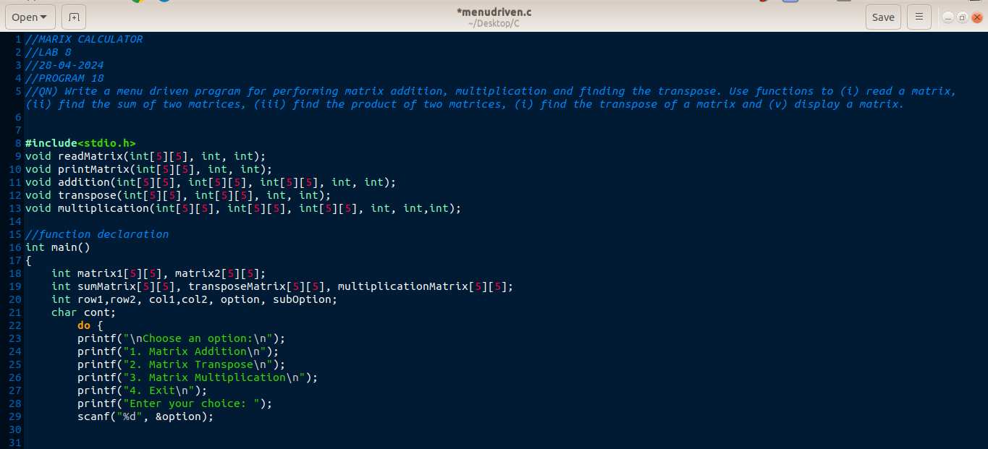

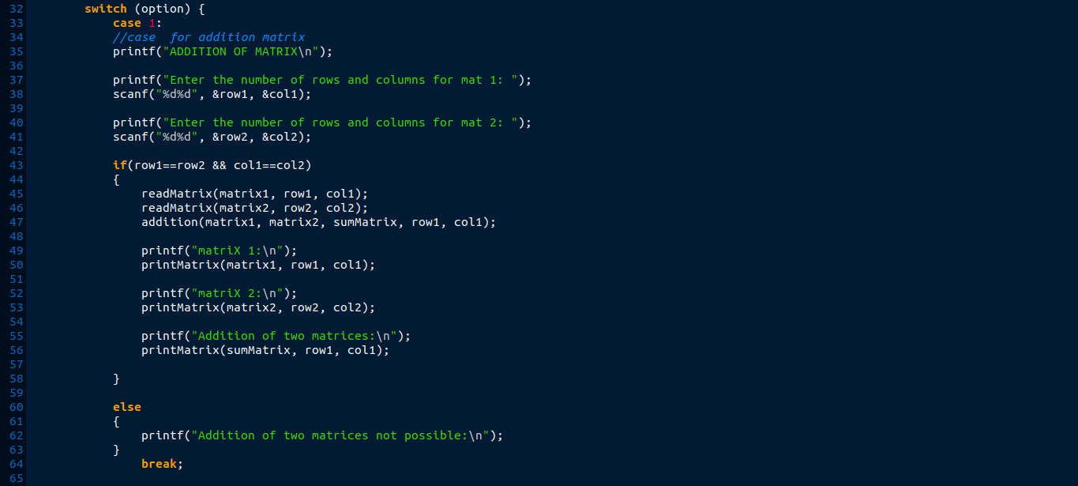
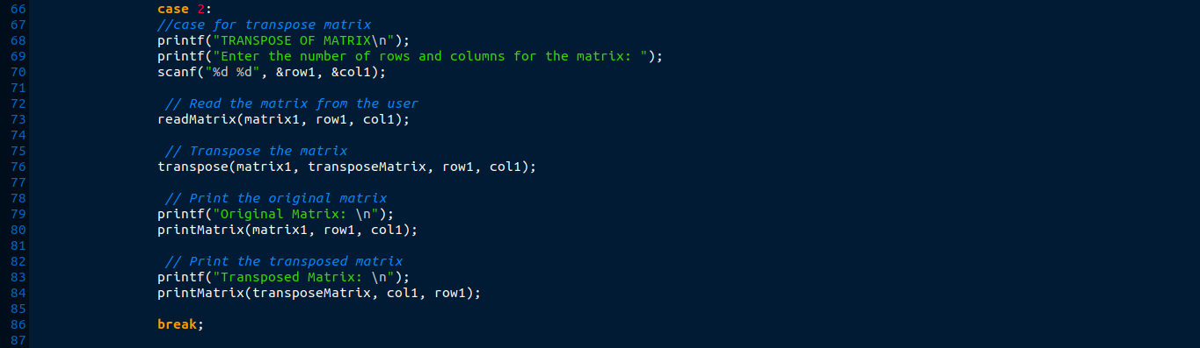
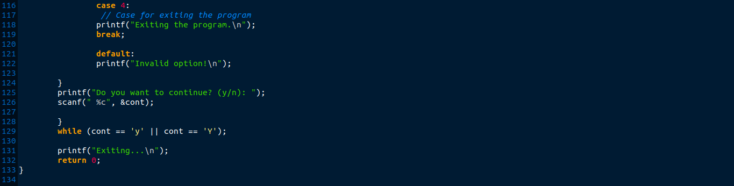
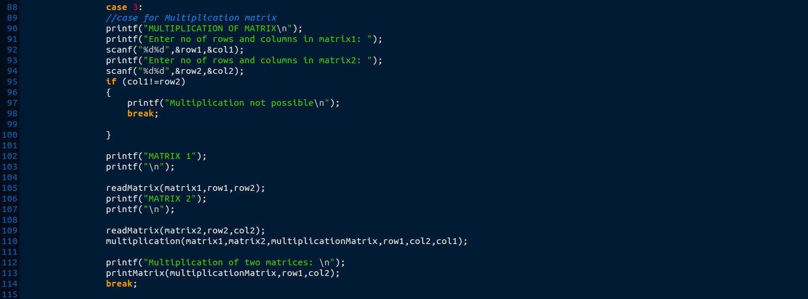

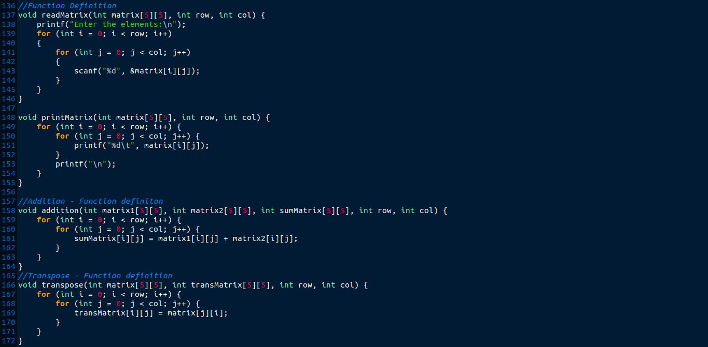
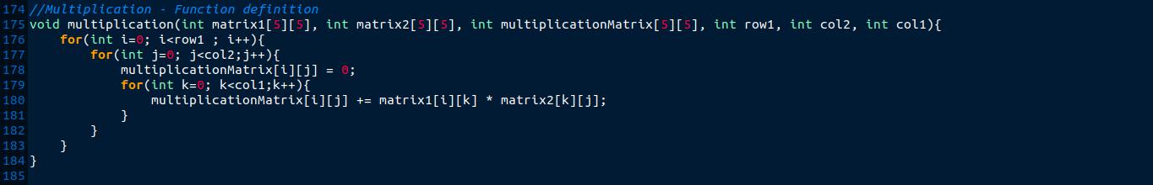

OUTPUT

(i) ADDITION
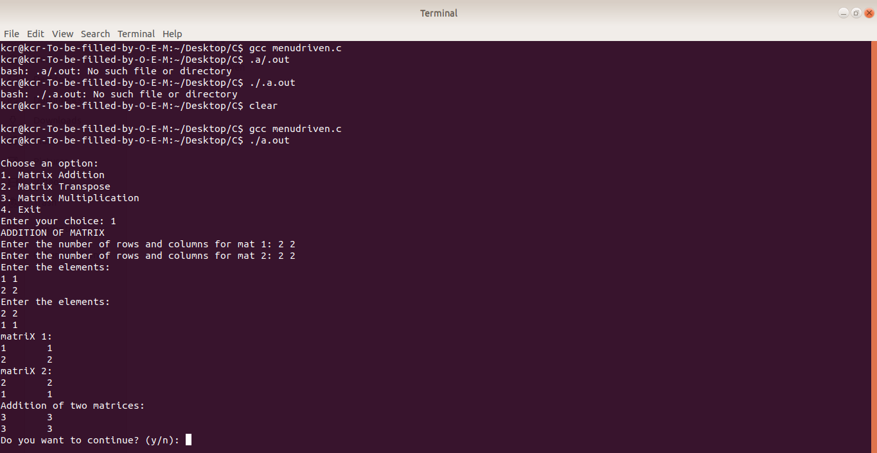
(ii) TRANSPOSE
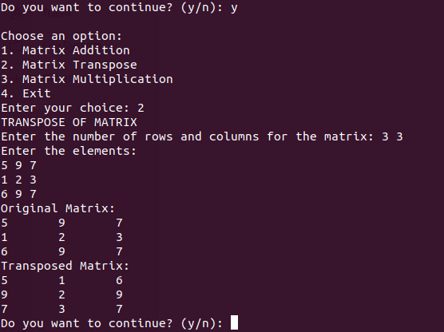

(iii) MULTIPLICATION
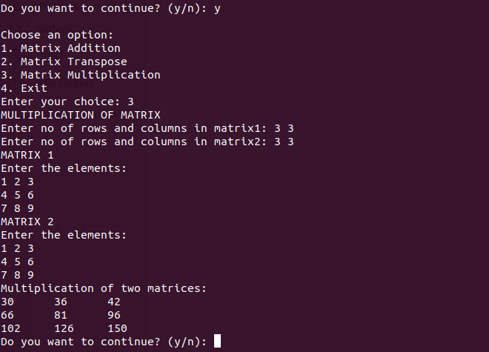
(EXIST)
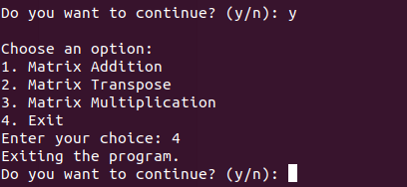

Yes or no


